Information on tourist spots around Ojiya

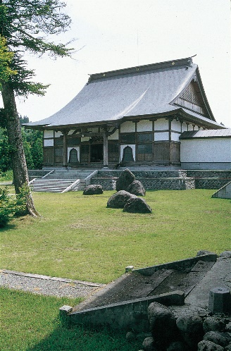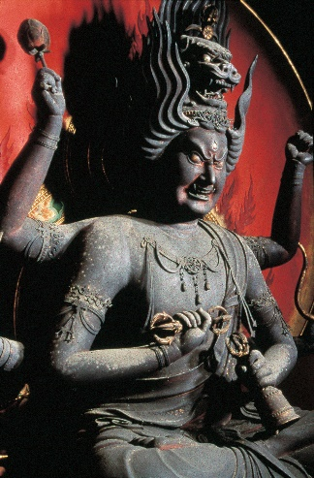
Myokō-ji temple Wooden seated statue of Aizen Myōō (Ragaraja)

The statue is 210cm tall and without a pedestal 119cm. It is made with cypres and he sits on a lotus upon a nectar vase. Six armed and three eyed ragaraja has hair standing straight-up and a crown of a lion on top. The first hands represent good health, holding a bell on left and a five-pronged vajra on right. The second hands represent love, respect and peace, holding a bow on left and a arrow on right. Lastly the third hands represent the importance of overcoming anxiety and temptation, clenching the left fist and holding a lotus on right.
Aizen Myōō has been worshiped for family safety, prosperity of business, good luck, traffic safety, matchmaking, good health, keeping off disasters, dyeing and brewing It is told that he saves our lives by burning our worries and concerns out with the fierce look.
It was designated as a national treasure in 1935, and since world war Ⅱ it was designated as a national important property in 1950.
The festival of Aizen Myōō is annually held on the second Saturday of June. Many people come to worship Aizen Myōō and you can enjoy a firework display, streets stalls and some performances.

Website URL: http://www.myoukouji.com/
Address: 114 kawai, Ojiya-shi, Niigata

